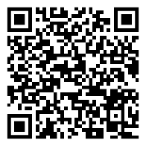 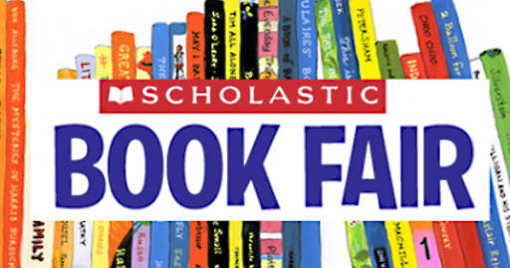

**Open for book sales in the library:**

|  |  |
| --- | --- |
| **Friday, 4/14** | **12:00pm-5:00pm** |
| **Monday, 4/17 **Family Event** | **9:45am-12:30pm**  **\*\*4:30pm – 6:00pm** |
| **Tuesday, 4/18** | **9:45am-12:30pm** |
| **Wednesday, 4/19** | **9:45am-2:00pm** |

*We need volunteers! Sign up here:  
 <https://volunteersignup.org/AP449>   
*Books can also be purchased online 4/11 - 4/24  
 <https://www.scholastic.com/bf/ceseagles>

*Students will be able to shop the book fair during the school day in the CES Library and we will also have Family Events outside of school hours.

*A percentage of all sales goes to CES PTA.

* Sales tax will be charged (6%).

*eWallet! This is our preferred form of payment. Parents set up a secure eWallet account using the CES Book Fair Homepage and add funds to it online. Students and cashiers will know how much money they have available to spend at the bookfair, so students don’t have to worry about carrying around or counting cash. EASY!  
  
Credit card (adults only) or check purchases may be used.   
(Make checks out to CES PTA.)



Set up eWallet here!

**The Scholastic Book Fair is coming to CES!**

**PTA SCHOLASTIC BOOK FAIR**

**Apr. 14th - Apr. 19th**